SCH4C November 2017
Answers for Review for Test #2: Quantities in Chemistry
Name:
- In what ways are the terms dozen and moles similar?
Both refer to how many of something

- Determine the number of significant digits in the following.
- 2051 4 | - 0.236 3 | - 0.001 1

- How many decimal places should be recorded in the following calculations?
- 10.1 + 20.6  1 decimal places | - 2.15 + 1.001  2 decimal places | - 2.2 + 2  0 decimal places

- How many significant digits should be recorded in the following calculations?
- 15 x 25.0  2 significant digits | - 150 /22.5  3 significant digits | - 136/125.65  - significant digits

- Name the following pieces of equipment that we have used in this unit. What is it used for? How is it used?
Equipment | What is it used for? | How to use it/special instructions?
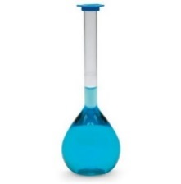 | - To obtain an exact volume measurement  - Used for making standard solutions | - Add water until the bottom of the meniscus reaches the scratched line
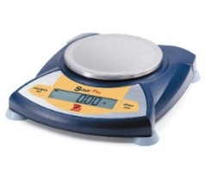 | - To measure out mass | - Make sure that it is zeroed first
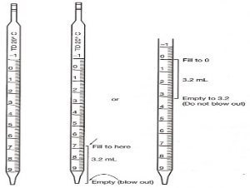 | Used to obtain a small exact volume of a liquid | - Need to attach a pipette bulb
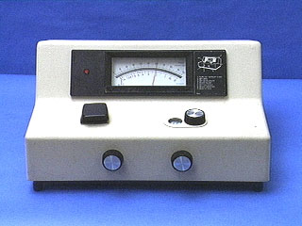 | SPECTROMETER  Used to measure the amount of light absorbed by a coloured solution | - Special test tube must be lined up  - Zeroed with water  - Need to have a graph of absorbance vs concentration to determine the concentration of an unknown
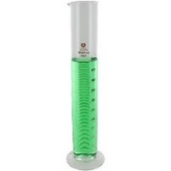 | - Used to measure volume – not as exact as a pipette | Measure to the bottom of the meniscus

- Match the following units with the correct symbol.
Symbol | Units
m g | mL or L
V mL or L | mol/L
mm g/mol | g
C mol/L | mol
n mol | g/mol

- Calculate the molar mass of the following.
- Br  79.90 g/mol | - Cl₂  2x 35.45  70.90 g/mol | - KBr  - + 79.90  119.00 g/mol
- Na₂O  2x22.99 + 16.00  61.98 g/mol | - C₃H₅OH  3x12.01 + 6x1.008+ 16.00  58.08 g/mol | - Pb(SO₄)₂  207.2 + 2x32.06 + 8x16.00  399.32 g/mol

- Convert the following volumes to L
- 250 mL  0.250 L | - 15 mL  0.015 L | - 5 mL  0.005 L

- Determine the number of moles (n) for the following:
[FORMULAS to USE: n= m/mm or n = C x V ]
- 15.0 g of KBr (mm=119.00)  n = m/mm  = 15.0/119.00  = 0.126 mol | - 0.15 g of H₂O (mm = 18.02)  n = m/mm  = 0.15/18.02  =0.0083 mol
- 25 mL of 0.10 mol/L NaCl (V=0.025L)  n = c x v  = 0.10 x 0.025  = 0.0025 mol | - 2.0 L of 0.50 mol/L KBr  n = c x v  = 0.50 x 2.0  =1.0 mol

- Calculate the mass (m) of the following substances:
[FORMULA to USE: m = n x mm ]
- 1.5 mol KBr (mm = 119.00)  m= n x mm  = 1.5 x 119.00  = 178.5 g  (180) g | - 0.222 mol of C₃H₅OH (mm=58.08)  m = n x mm  = 0.222 x 58.08  = 12.893 g  (12.9)

- Calculate concentration (C) of the following solutions: [FORMULA to USE: C = n/V ]
- 5.0 mol (n) of KBr in 500 mL (0.500 L) of solution  C = n/V  = 5.0/0.500  = 10 mol/L | - 10.0 g (m) of Na₂O dissolved in 2.0 L (V) of solution (mm = 61.98)  n = m/mm  = 10.0/61.98  = 0.161 mol  C = n/V  = 0.161/2.0  = 0.0805 mol/L

- Calculate concentration (C) of the following solutions: [FORMULA to USE: C₁V₁=C₂V₂ ]
- 10.0 mL (V1)of 0.50 mol/L (C1)solution of KBr is diluted to a volume of 100 mL (V2)  0.50 x 10.0 = C₂ x 100  C₂ = 0.50 x 10.0  100  = 0.050 mol/L | - 5.0 mL (V1) of 0.10 mol/L (C1) solution of KBr is added to a 250 mL (V2) volumetric flask and water is added to the fill line.  5.0 x 0.10 = C₂ x 250  C₂ = 5.0 x 0.10  250  = 0.0020 mol/L

- Suppose that you are asked to make 500 mL of a 0.250 mol/L solution of NaCl. You will begin with solid NaCl.

- What two pieces of equipment will you need?
Balance and volumetric flask

- What is the volume of the solution that you will be making?
500 mL = 0.500 L

- What must you do to the volume before you can begin to use it in a calculation?
Change to L

- What is the first calculation that you must make?
Find moles

- What is the second calculation that you must make?
Find mass
- Go ahead and make these two calculations.

Calculation 1 | Calculation 2
n = c x V  = 0.250 x 0.500  = 0.125 mol | m = n x mm  = 0.125 x 58.44  = 7.31 g

- Describe how you would go about making this solution to a student who has never made a standard solution before. Include all amounts and equipment in your description.
- Zero the balance with beaker on it
- Mass out 7.31 g of NaOH
- Add water to the beaker (less than 500 mL) and stir to dissolve
- Pour into the 500 mL volumetric flask
- Add water until the bottom of the meniscus reaches the fill line

- Suppose that you are asked to make a 250 mL (V2) solution of a 0.100 mol/L (C2) NaOH. You are given a 1.0 mol/L (C1)solution of NaOH.

- What two pieces of equipment will you need?
Volumetric flask and pipette

- What volume (V1) of the 1.0 mol/L solution will you need?
C₁V₁=C₂V₂
1.0 x V₁ = 0.100 x 250
V₁= 25 mL

- Describe how you would go about making this solution to a student who has never made a standard solution before. Include all amounts and equipment in your description.

- Using a 25 mL pipette, measure out 25 mL of the 1.0 mol/L solution
- Pour this into the 100 mL volumetric flask
- Add water until the fill line is reached
15. Lab-based question
A student is asked to determine the concentration of a solution of KBr. He does so by removing 10.0 mL of the solution of KBr from a container and evaporating away the water portion of the solution. He determines that 1.23 g of the solute, solid KBr, is left behind.
- What volume of solution, in L, was removed from the container?
10. mL or 0.010 L

- What mass of KBr was in the solution that was removed from the container? 1.23 g

- How many moles of KBr was in the solution that was removed from the container?

n = m/mm
= 1.23/119.00
= 0.0103 mol

- What is the concentration of the solution of KBr?
C = n/V
= 0.0103/0.010
= 1.03 mol/L

